72095
VIS#023939

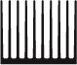 |  | Part  Number | Thermal Resistance  °C/W at 3in length | Width  in | Height  in | Surface Area  in/n | Weight  lb/ft
 |  | 72095 | 1.57 | 2.60 | 2.19 | 44.6 | 2.30
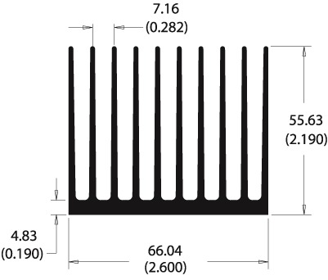
Thermal Curves
based on 3.000 in length
Top of Form

Bottom of Form

Natural Convection
 | Heat Sink Temperature Rise  Above Ambient |  |  | Heat Sink  Thermal Resistance
  25.0
  18.8
  12.5
  6.2
  0.0
   | 1.0 | 3.0 | 5.0 | 7.0 | 9.0
  7.00
  5.25
  3.50
  1.75
  0.00
   | 1.0 | 3.0 | 5.0 | 7.0 | 9.0
 | Power Dissipated (W) |  |  | Power Dissipated (W)

Forced Convection

 | Heat Sink Temperature Rise  Above Ambient (10W Dissipated) |  |  | Heat Sink  Thermal Resistance
 | Air Flow (m/s) |  |  | Air Flow (m/s)
   | 1.0 | 2.0 | 3.0 | 4.1 | 5.1
  15.0
  11.2
  7.5
  3.8
  0.0
   | 200 | 400 | 600 | 800 | 1000
   | 1.0 | 2.0 | 3.0 | 4.1 | 5.1
  1.50
  1.12
  0.75
  0.38
  0.00
   | 200 | 400 | 600 | 800 | 1000
 | Air Flow (LFM) |  |  | Air Flow (LFM)

Building a Part Number
Full Bar Length = 8.00ft
Base Part #
  Bar  Length | Finish | Length  (use zeros for full or half bars)
5 digit base part #
  1 Full (normally 8-ft) | F Unfinished | 0 0 0 0 0
5 digit base part #
  2 Half (small cut fee) | F Unfinished | 0 0 0 0 0
5 digit base part #
  3 Custom  (cut to specified length) | B Black Anodized  C Gold Chromate  U Unfinished*  V AavSHIELD³ | indicate length in inches  to three decimal places;  If the part is less than 10 inches, the first of these 5 digits (digit 7 of the 12 digit series) would be a zero (0).

_ _ _ _ _ | _ | _ | _ _ _ _ _
72095 | 1 | F | 0 0 0 0 0

Examples:
If you wanted to simply order extrusion # 72095 in standard bar form, the part number would be:720951F00000. The unit price would be sold by the foot.
If you wanted extrusion 72095 cut to a length of 6.500" and black anodized, the part number would be:720953B06500. The unit price would be by the piece.
If you wanted extrusion 72095 cut to a length of 14.725" and a wash finish, the part number would be:720953U14725. The unit price would be by the piece.
*For unfinished extrusions with cut lengths other than half bar, the finish designation is a U.
Standard Aavid Thermalloy parts require all 12 positions to be complete.

