For use with TO-220 packages
Part Number - 575002B00000
VIS - 002287
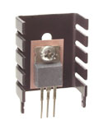

Mechanical Outline Drawing
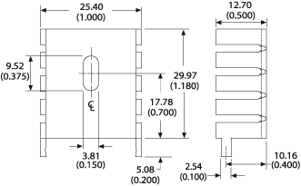
Thermal Curves  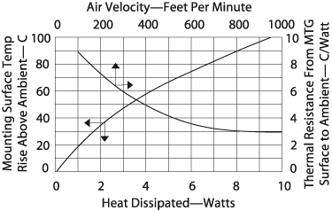 | Thermal resistance value is based on a 75°C rise in natural convection
  Thermal Resistance | 13.60
Product Information

Part # | Description | Finish
575002B00000 | Channel style heat sink with two integrated tabs | Black Anodize

